HTML 5

1. What are the new tags added in html 5?

Ans. The new tags added in html 5 is <audio>, <video>, <source>, <embed>, <track> .

<audio> -  An inline element that embeds sound files into a web page

<video>: Embeds video files

<source> and <embed> is a tag.

<track> : A tag that supports both audio and video

1. How to embed audio and video in webpage.?

Ans. By using an new tags like <audio> and <video> tags we can embedd audio and video in our webpage

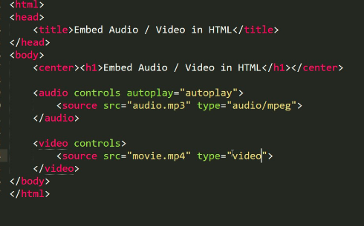

1. Semantic Elements in Html 5?

Ans. Elements such as <header>,<nav>,<section>,<article>,<aside>, and <footer>act more or less like <div> elements .

* They group other elements together into the page sections.
* However where a <div> tag could contain any type of information it is easy to identify what sort of information would go in a semantic <header> region.
* A semantic elements clearly describes its meaning to both the browser and the developer
* Examples of non semantic elements - <div> and<span> tells nothing about its content
* Examples of semantic elements - <form>,<table> and <article> = clearly defines its content

1. Canvas And SVG Tags?

Ans. The <canvas> tag is transparent, and is only a container for graphics, you must use a script to actually draw the graphics.

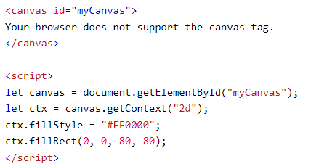

The <svg> tag defines a container for SVG graphics. SVG has several methods for drawing paths, boxes, circles, text, and graphic images.

